**Weather Application Widget – Instrcutions**

1. Source code for the solution described above.

https://github.com/nisarzahid/weather-widget-angular6.git

1. Setup/installation instructions

This application is build using angular 6. You need to have following installations:

* Node.js and npm
* Angular-cli (latest)
* After cloning the source code from git. Move inside the root directory (where package.json exist) and run npm install.
* Run ng serve inside the root folder where package,json resides.
* Open the browser <http://localhost:4200/>
* You will see the following interface

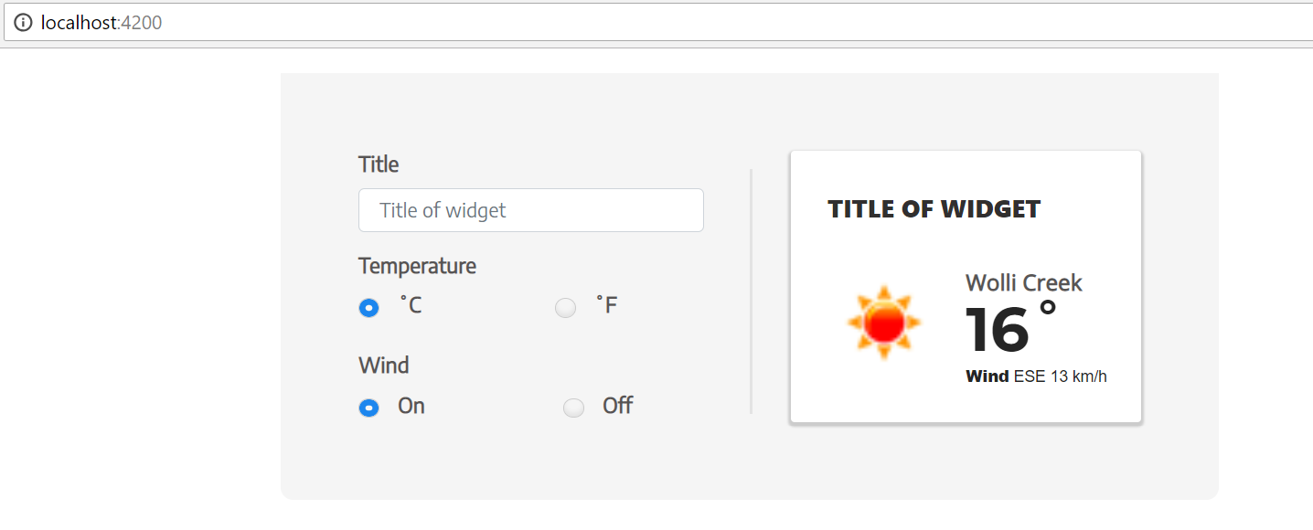

1. A quick (1 page) description of your solution, outlining anything of interest about the code you have produced. This could be anything from why you chose the language and or libraries, why you structured the project the way that you did, why you chose a particular error handling strategy etc

Application is build using Angular 6

Angular is widely used frontend javascript framework, I have the expertise in that.

Application takes the user current coordinates from the browser api navigator.geolocations and then using those coordinates it calls the openweathermap api to fetch the current weather conditions and display it on widget screen. You can edit the Title of the widget as well re-form the weather info by changing Temperature format and wind condition.

Application source code consist of following parts:

* **AppModule**

This consist of root component app.component which is bootstrap by default in browser when application runs.

* **WeatherWidgetModule**

This is standalone weather widget module which can be exported and imported anywhere to this application and also to externally. It consist of following parts:

* **WeatherWdigetComponent**

This is the html/css and typescript file of complete widget screen you are seeing on screen. It will be rendered anywhere if you add this component selector. Like I did in App.component.

<app-weather-widget></app-weather-widget>

* **Weather.Service**

This is http service to make http call to OpenWeatherMap api. The service is injected into component using dependency injection.

* **Environment variables**

These are inside the environments folder at the root. It contains environment flags for dev and production for following variable values

* production: sets to true when build using –prod command
* appId: OpenWeatherMap api provided app key id.
* baseUrl: Base url to make http call for openweathermap ('http://api.openweathermap.org/data/2.5/')
* units: default unit for temperature – currently sets as imperail

1. A list of assumptions that you’ve made while putting this together. We’ve only given you a very loose spec, so you’ll probably need to fill in some blanks while you are working. If you note down the assumptions, for us, then we will be able review the code within the context of those assumptions.

* Application assume you have setup for Angular 6 and Node.js on you machine.
* Application assumes that browser have allowed to get the user location.
* Environment variables are used to set the OpenWeatherMap app key id and baseUrl. Change the values appropriately.

1. [Optional] Tell us what you thought of the test and how long it took you to complete

I found application requirement fairly easy to understand. It took me less then couple of hour build the frontend solution in Angular6.